Boodlebox Signup and Login Steps
Navigate to the Boodlebox Signup Page
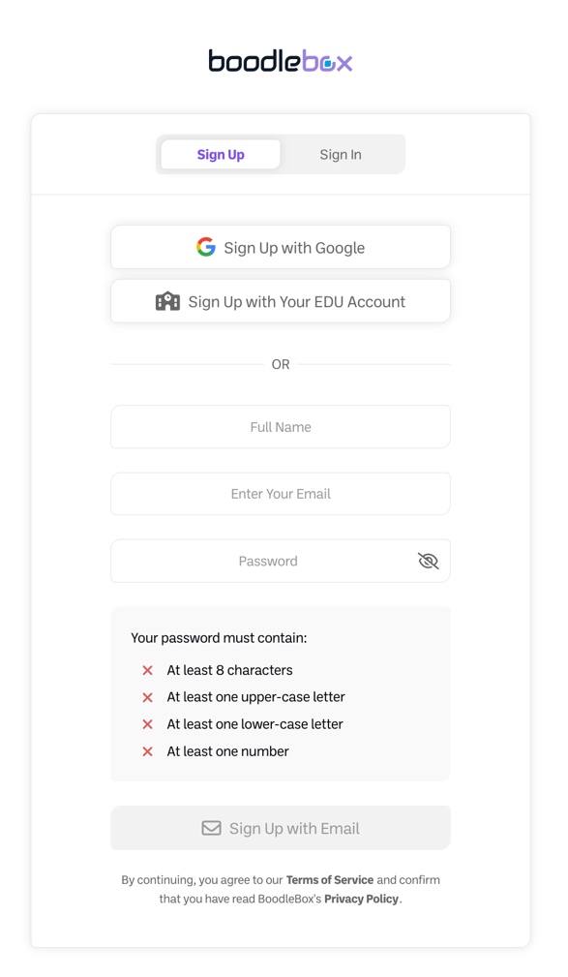
NOTE: Do not use this button unless you already have a paid account through your institution.
1. Click Sign Up
5. Click Sign Up with Email
4. Create a Password
3. Use your Preferred Email
2. Type In Your Full Name
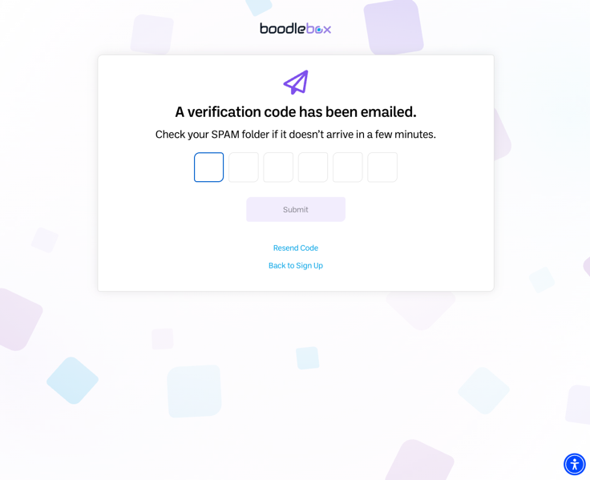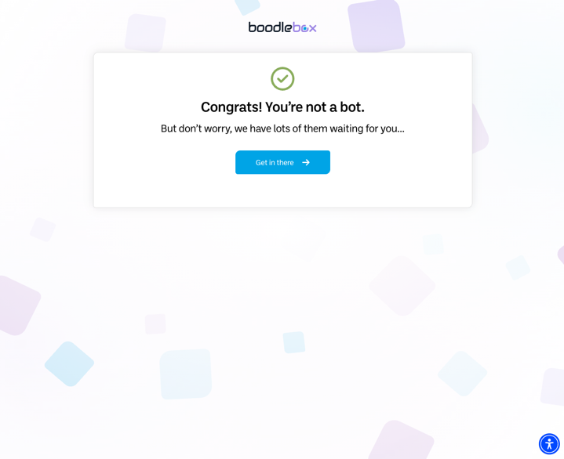
6. Check your email and
enter provided code.
NOTE: It may be in your junk mail folder!
8. Click “Get in there”
7. Click Submit

Select Educator & Administrator:
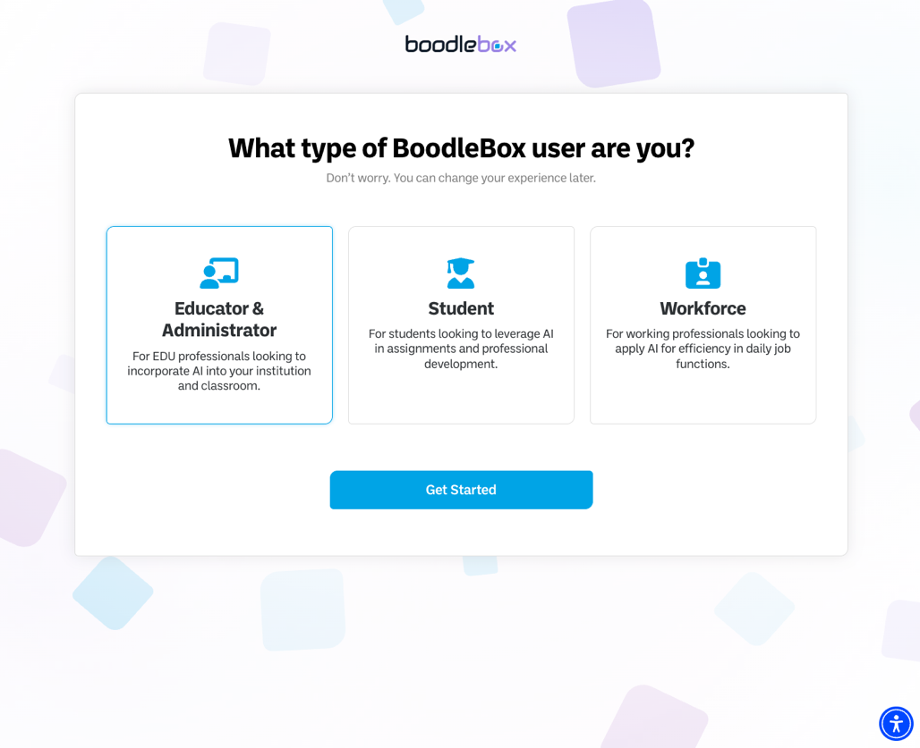
9. Click here (this can be changed later)
10. Click “Get Started” to jump into Boodlebox

Then Stop on this page, but don’t close it.
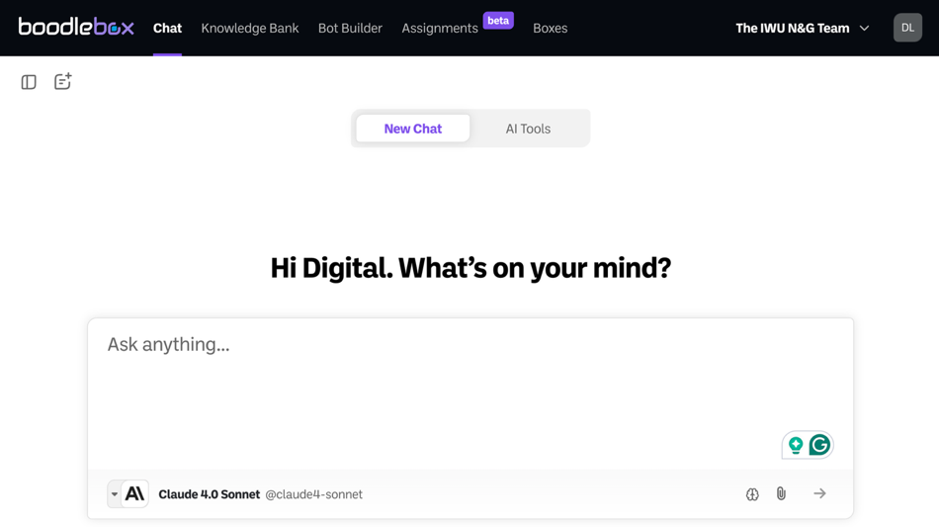
SAMPLE ONLY
Join the OLC Team
Fill out this form so we can add you to the OLC Team: OLC GAME WORKSHOP TEAM REGISTRATION
Alt Link: https://app.smartsheet.com/b/form/5639f7fa3be042bd924ea1dd915eb464
NOTE: Once you have been added, you will receive an email with the next steps (check your junk mail). If you are doing this ahead of the workshop, there will be a delay as I will wait to add these in groups.

